Newsletter
Issue 16

12 January 2024

Dear Parents and Carers,

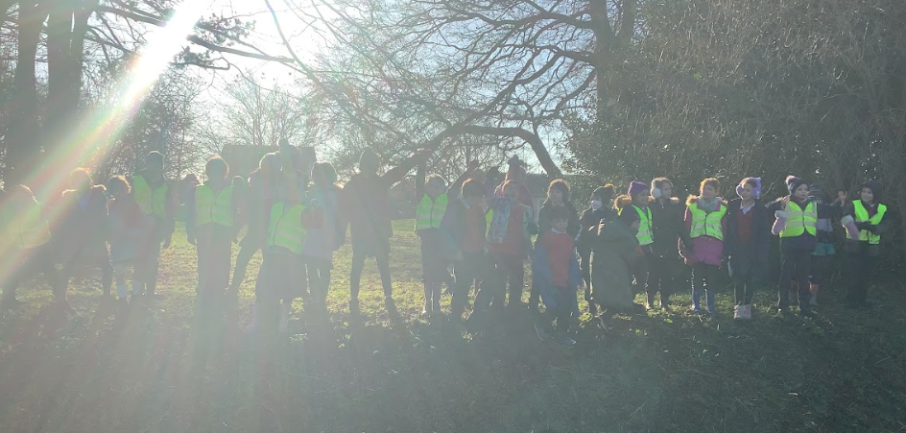
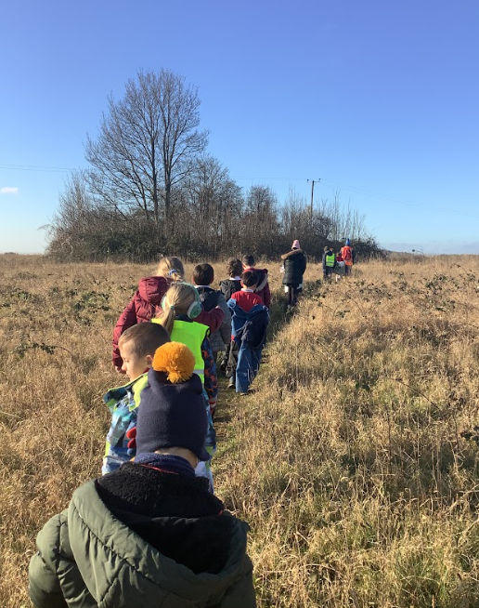
Year 4 went on a local walk to the Earthworks, where Anglo-Saxon artefacts and a skeleton were found in the 1930s! They then to the Tumulus which is an ancient burial mound.
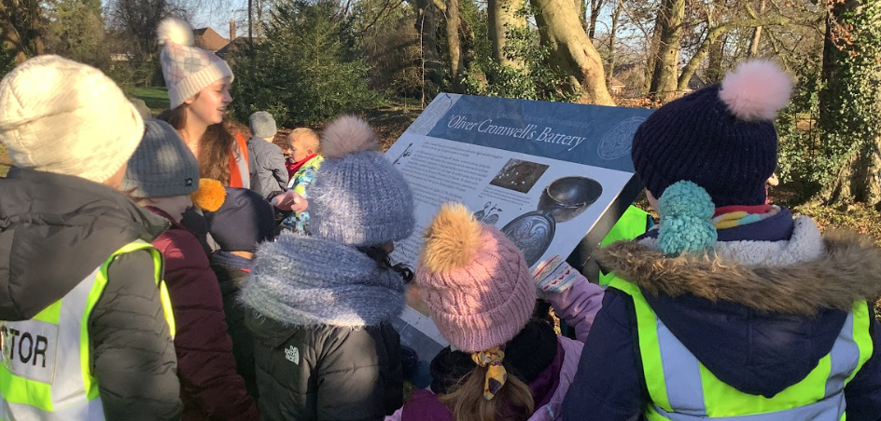

Boys Football
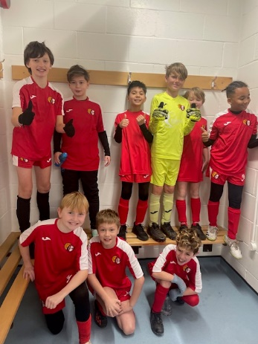
Today the boys’ football team accompanied by Mrs Langridge attended the Saints tournament.
This year there were 32 teams from across Hampshire to battle it out with. During the first stages they won some, lost some and also drew but their perseverance paid off to get them to the quarter finals. It was during this match you could see they were determined to win and scored a goal to take the lead. The other team equalized the playing field with five minutes to spare but still our boys battled on. However, in the final seconds of the game we conceded a goal knocking us out of the tournament. Overall the boys finished in 6th place and Mrs Langridge and Mr Sleeman, along with the rest of us are proud of them. WELL DONE BOYS!

Spanish Lessons
We are pleased to announce that we will be able to offer Spanish lessons at school. These will be run by an outside club and will be taking place on Tuesday lunch times starting on Tuesday 16 January. The cost will be £8.00 per session. For more information go to: www.spanish4kids.co.uk or email: spanish4kidshants@gmail.com or telephone 07971 213619. If you would like to book a trial lesson to give your child a chance to try Spanish club go to: https://spanish-4-kids.classforkids.io

After School Club – advance notice of club closure.
Due to staff training taking place there will be NO After School Club on Wednesday 17 January. School will be open as normal on that day.

Apologies for any inconvenience.

Football Club
We have been approached by a football coach who is interested in running an after school football club for Years 3 and 4 (Girls and Boys). This will be run by a private company at a cost of £7.00 per child per week. If your child is in Year 3 or 4 and is interested please can you let the school office know so we can gauge interest.

Tech Camps
Winnall Primary School and John Keble School in Hursley will be running Technology STEM camps over the February half term for ages 5-12. Please see the attached leaflet for more information.

Learning Behaviours
We have held this week’s Learning Behaviours assembly. This is where a teacher chooses a child/children that has demonstrated the chosen learning behaviour of the week. The teacher shares with everyone what the child has done and then we all celebrate their achievement. This term we are looking a co-operation. The children who were chosen this week were:

Year One Andi
Year Two Evie B
Year Three Kyra
Year Four Lois
Year Five Zac
Year Six Harper and Felicity

School Lunches
Thank you to everyone for settling their lunch accounts, however the lunch debts are still high - please could you ensure that your account is kept up to date. For your information the money owed per class is as follows:-
Hares £ 120.33
Foxes £ 80.75
Herons £ 152.40
Kingfishers £ 151.00
Nursery £ 87.00

Your child will not be able to order a school lunch if the debt is above £10.00 – if the debt is over £10.00 they will need to bring in a packed lunch. Please can you arrange to clear your Lunch accounts as soon as possible.

If you would like an up to date statement of your child’s account please contact the Admin Team. If you have not yet registered to pay online via Scopay and would like a copy of your login details please email us and we will be happy to help. We would appreciate it if all accounts, including any outstanding Breakfast Club and After School Club accounts, could be settled as soon as possible. Please ensure that your After School Club Account is up to date as we employ extra staff for this club. If you would like an up to date statement please contact the school office.

Thank you for your continued support.

Yours faithfully

Mrs Bordoli
Interim Headteacher
Dates for your diary (new dates in red)

Year R school applications close 15 January 2024
No After School Club 17 January 2024
Year 6 residential trip to Calshot 16 - 19 January 2024
Inset Day 19 February 2024
Year 5 trip to Ferny Crofts 24 - 26 April 2024
Inset Day 28 June 2024
Inset Day 1 July 2024

